How to Add keystore.p12 to the Windows Trust Store for FieldAnalytics
To prevent HTTPS insecure connection warnings, follow these steps to import the keystore.p12 file into the Windows trust store.

Step 1: Navigate to the Certificate Directory
Go to the following path:\nC:\Program Files\SICK\FieldAnalytics\DynamicDashboard\certificate\nOr, if FieldAnalytics is installed in a custom location:\n<FA installation location>\DynamicDashboard\certificate
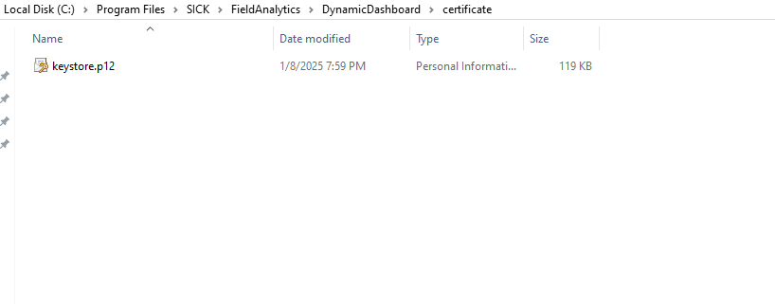

Step 2: Open the Keystore File
Double-click on keystore.p12.

Step 3: Certificate Import Wizard
1. Choose Current User or Local Machine, then click Next.
2. Click Next again on the following screen.
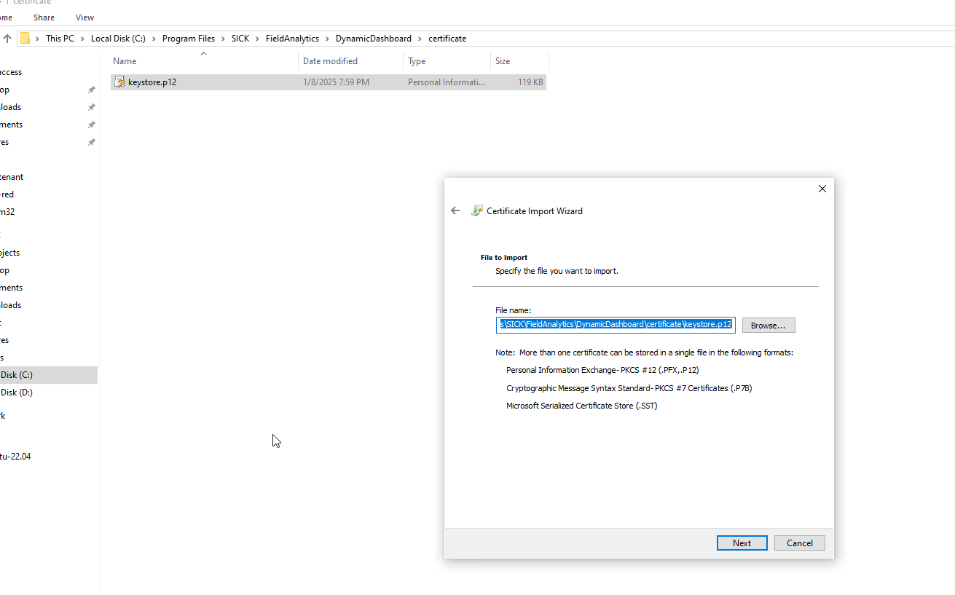
3. If prompted for a password, it will be provided to you directly as needed.
4. On the next screen, select 'Place all certificates in the following store'.
5. Click Next, then Finish to complete the import.
