How to read the process data via IO-Link from the senor CSM.
We use a Siemens 1200 CPU and our Profinet IO-Link master IOLG2PN.
We works with the TIA-Portal V13.
So we want to know how to interpret the process data which you can see in the OI
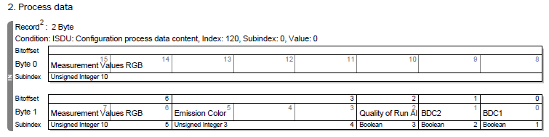
The tricky thing in this case is that you get every IO-Link cycle another emission Color and for that emission color the measured value. So if the emission color is “0” you get the measured value for Red, if the emission color is “1” you get the measured value for Green and if the emission color is “2” you get the measured value for Blue.
All measured values together are the color in front of the sensor.
For example:
We use our ProcessData parcer which you can find at our Website.
We have to create two variable in the Data block (DB) in this case the DB call DB_ProcessData_CSM. The First Variable names “ProcessData_CSM” and is from the Type “ST_SICK_PDInParser_CSM”, second variable names “Error_Code_PD_CSM” and is from the type “Word”.
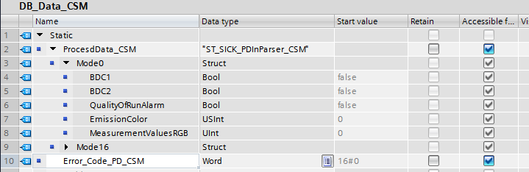

Than we go to the Main program and put in our Parser “F_SICK_PDInParser_CSM” with this function you get the Process Data in the structure like you can see in the DB above, not only 2 Byte which you have to split by yourself.
It looks like this.
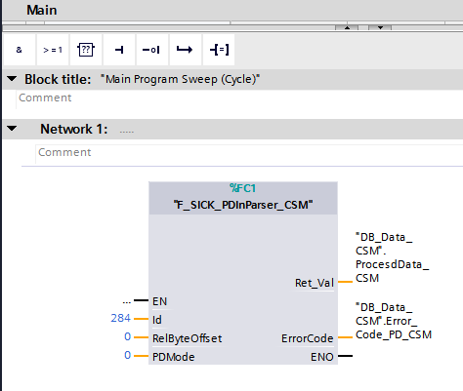

The ID you will find in your hardware config, it is the Hardware identifier of the IO-Link port.
Than the RelByteOffst is 0, with our Master it is always 0 only if you use another Master you need it, how you read in the manual.
PDMode is 0, at the CSM you can choose between two process data modes like you can see in the OI, we use Mode 1 because we want to see the RGB values.
“Ret_Val” are the datas you will get from the sensor we put in the Variable “ProcessData_CSM” which we create before in the DB.
And the last is the ErrorCode, here we use the variable Error_Code_PD_CSM which we also create in our DB. Here you can see the error message of the Parcer for example invalid process data, more error codes or the meaning of them you will find in the manual of the function block.

Now to get the correct RGB value we have to assign the measured value to the emission color. I make it with a simple “Compare” and “Move” function. For this we create again 3 variables in our DB, one for Red, one for Green and one for Blue, all of type “UInt”.
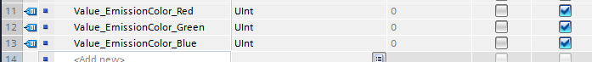
In the program it looks like this. For example with emission color Red.
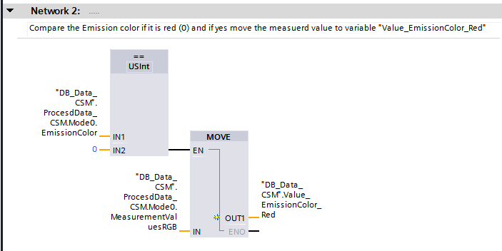
The same for the other 2 emission colors.
So now we have the measured RGB value like you can see in the screen shot below. I put in a watch table the created variables to show the RGB values.
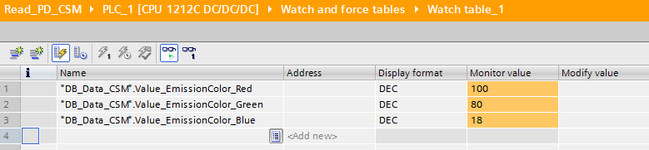
So this is the measured value of the sensor. R is 100, G is 80, B is 18.
Do to the fact that the calibration of the sensor is at 100% (white) for all three values you have to calculate by 255 to get the color
for example in this case
R is 100 -> 1 * 255 = 255
G is 80 -> 0,8 * 255 = 204
B is 18 -> 0,18 * 255 = 46
=>>> the result is yellow.

