Target | Intensity | Targetposition [mm] | Picture
DG | 25% | 15000 | 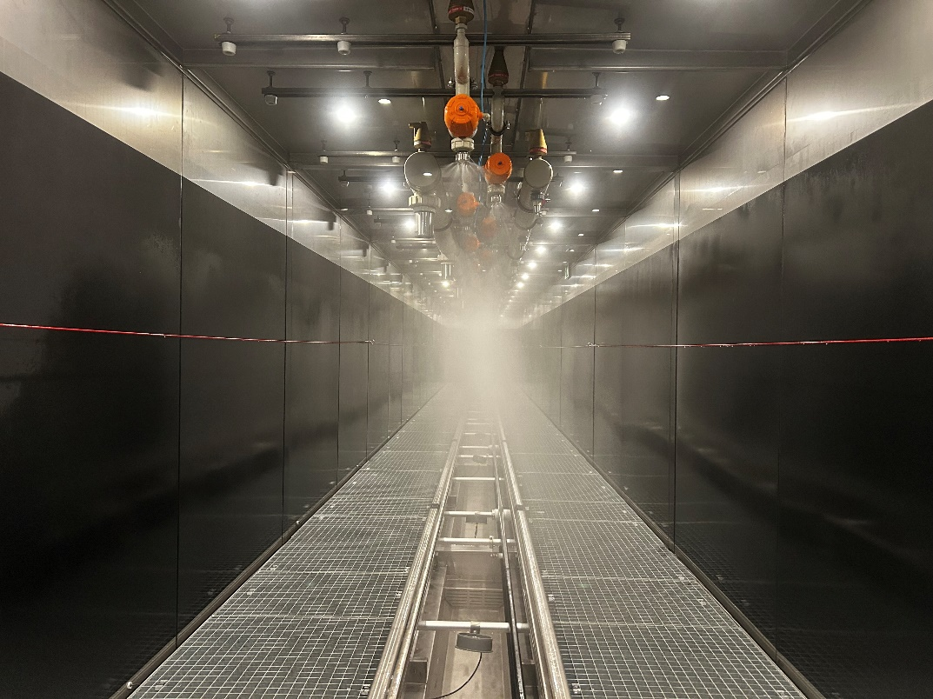
DG | 25% | 13000 | 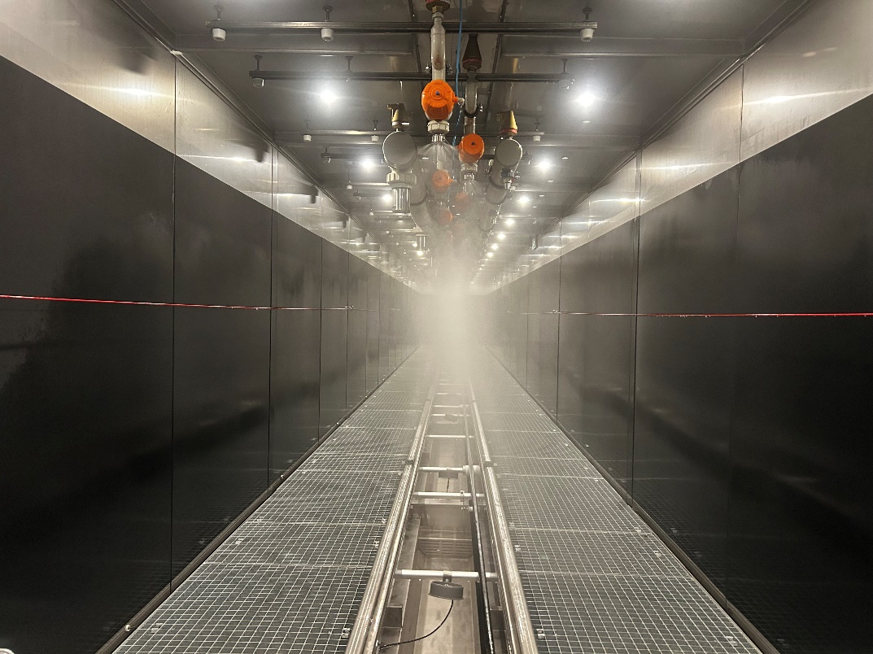
DG | 25% | 9000 | 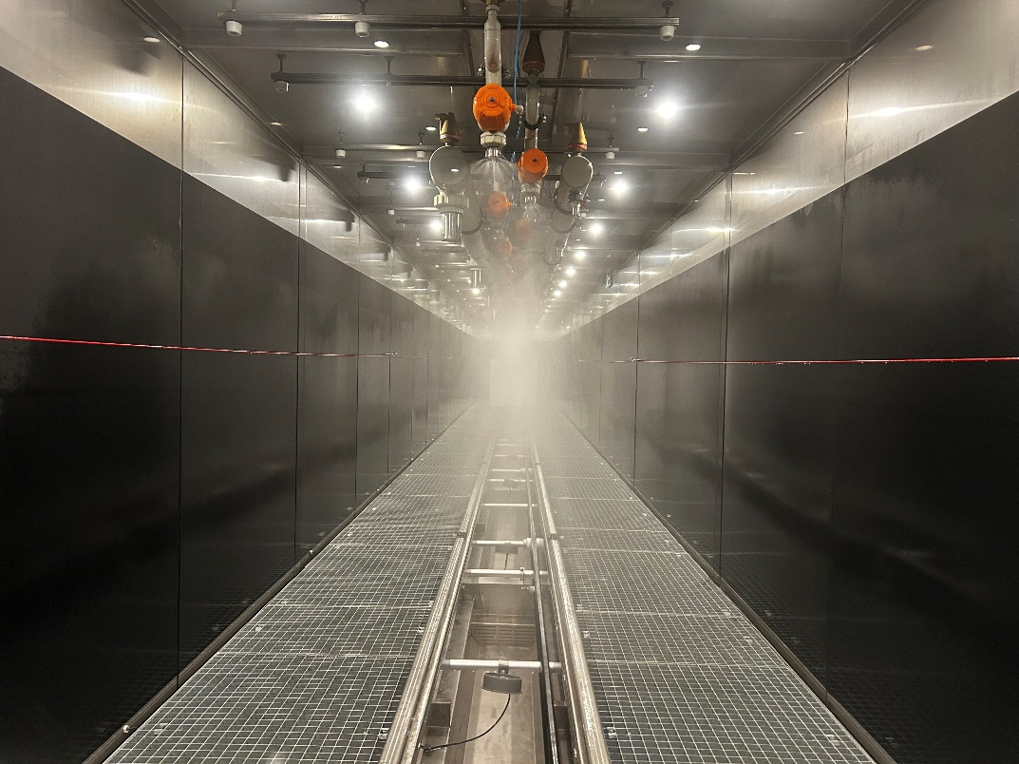
DG | 25% | 7000 | 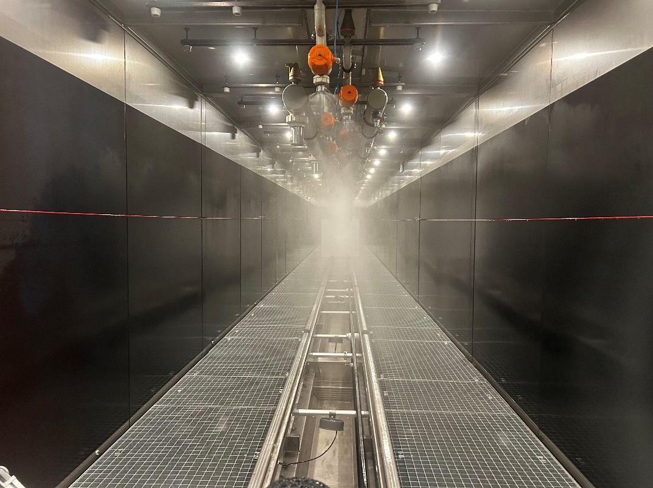
DG | 25% | 6000 | 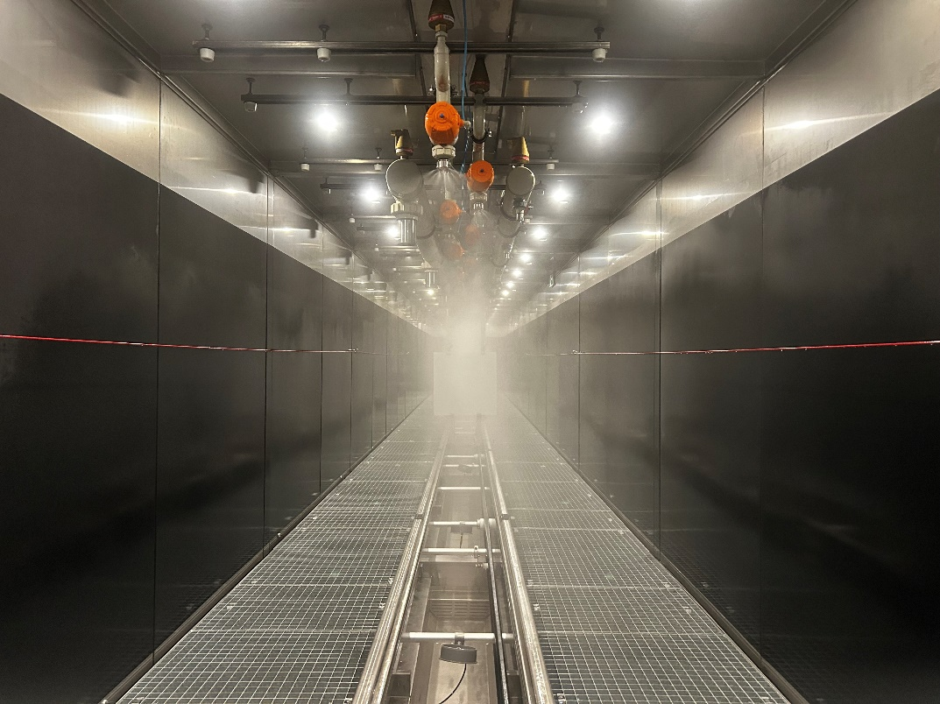
DG | 25% | 3600 | 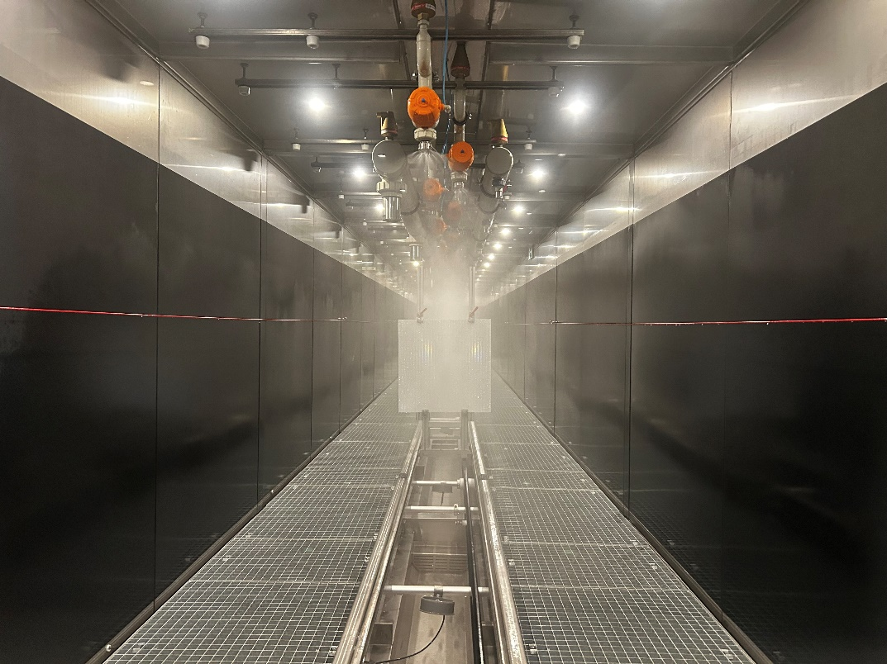
DG | 25% | 2300 | 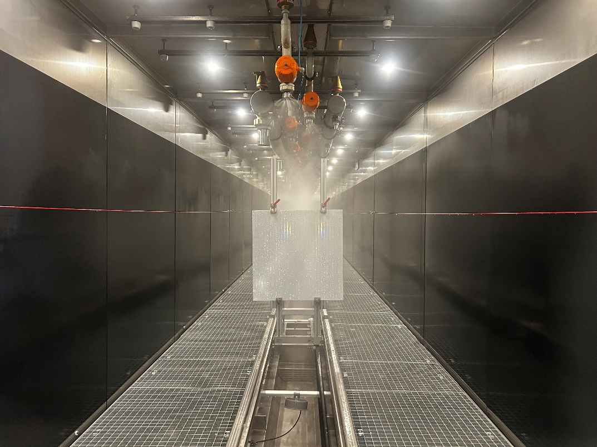
DG | 25% | 60 ... 18000
DG | 50% | 10000 | 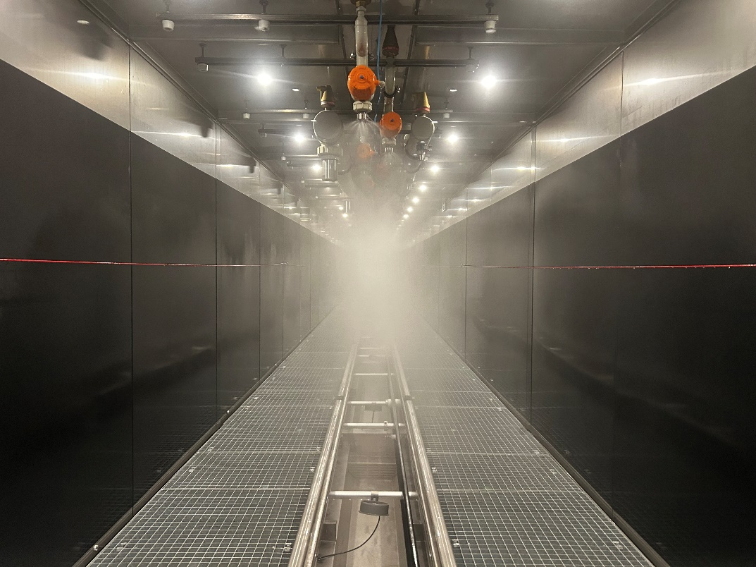
DG | 50% | 9000 | 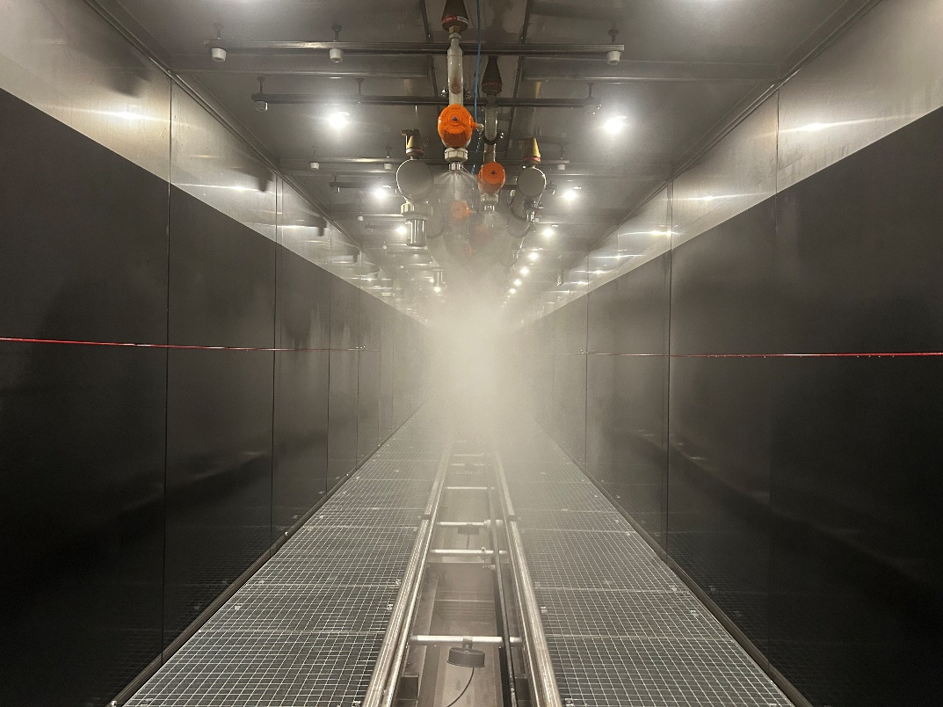
DG | 50% | 7000 | 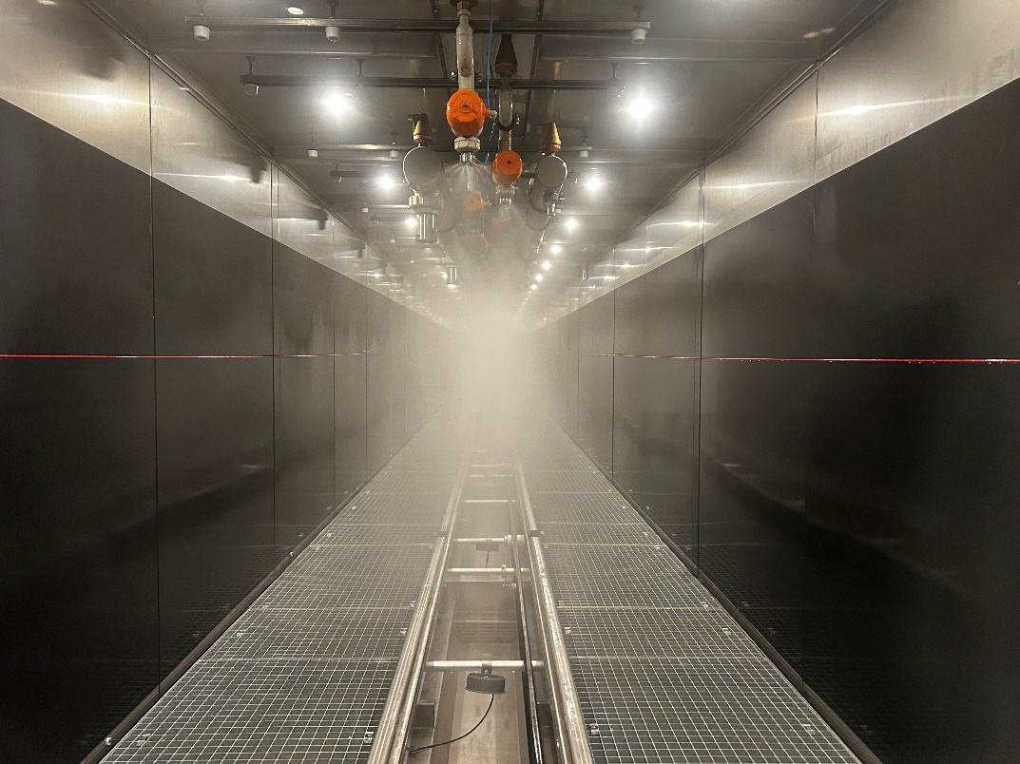
DG | 50% | 6000 | 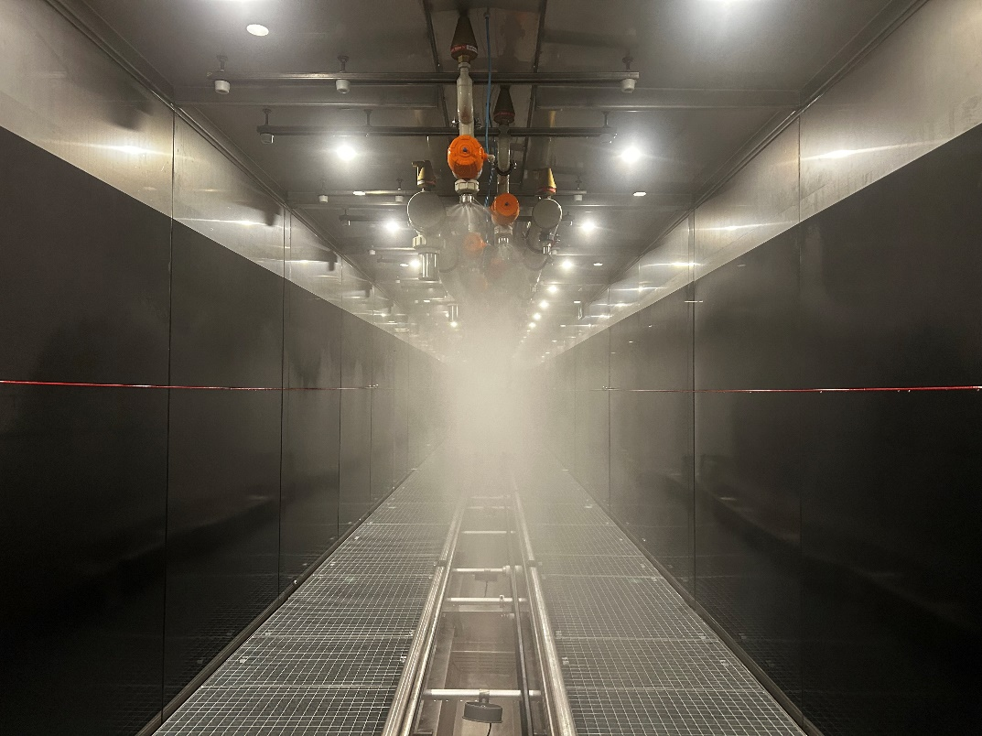
DG | 50% | 3600 | 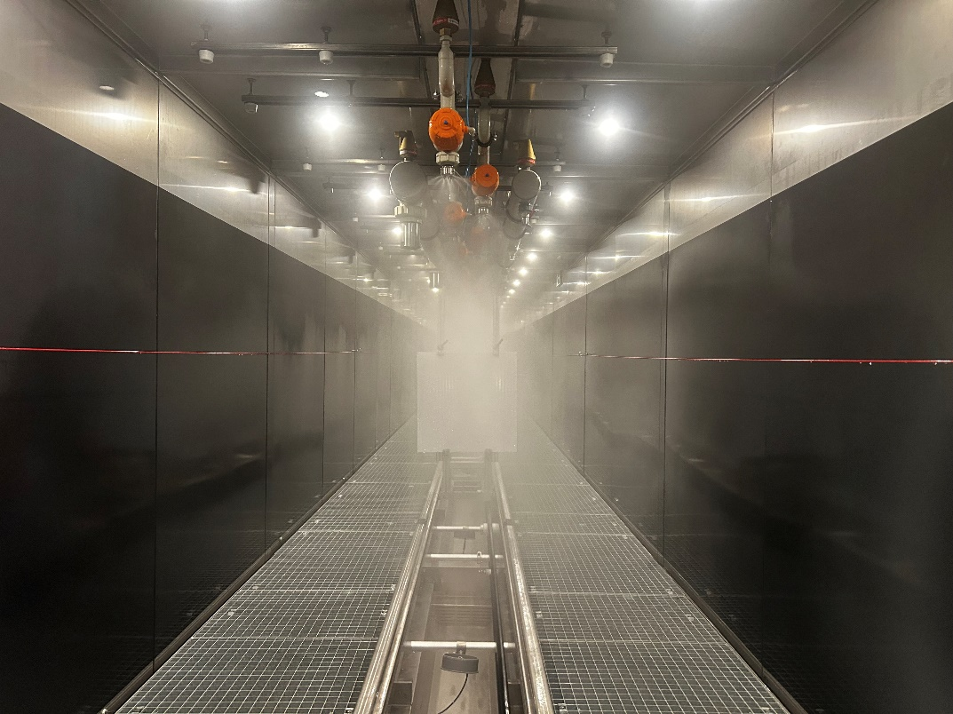
DG | 50% | 2300 | 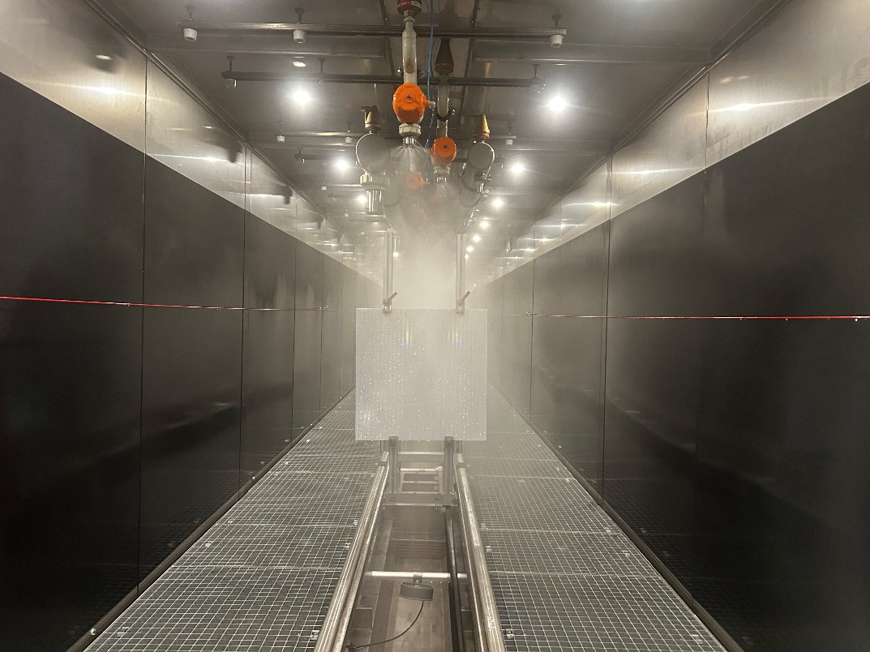
DG | 50% | 60 ... 18000
DG | 75% | 8000 | 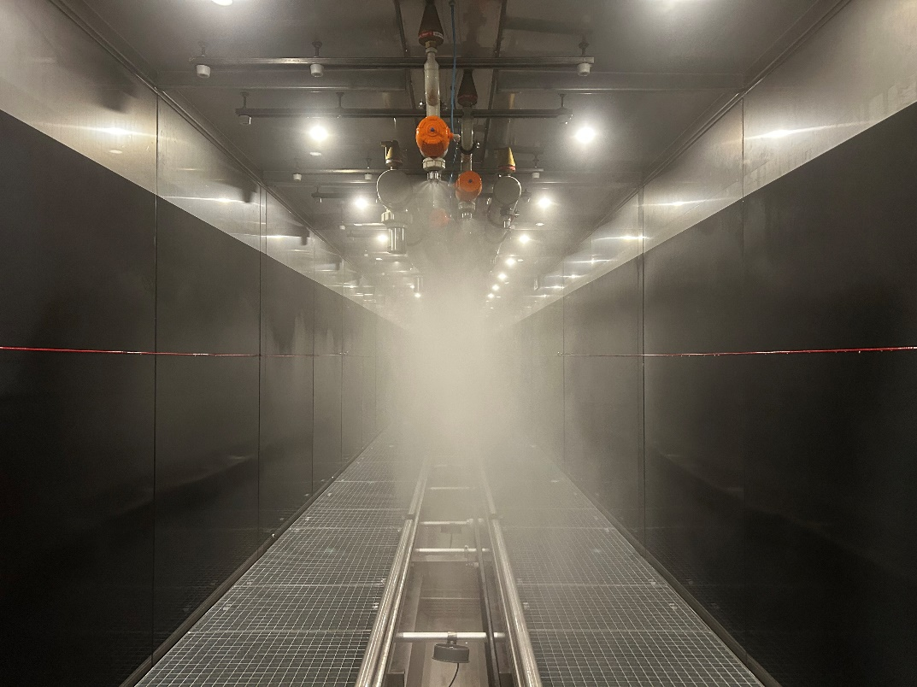
DG | 75% | 7000 | 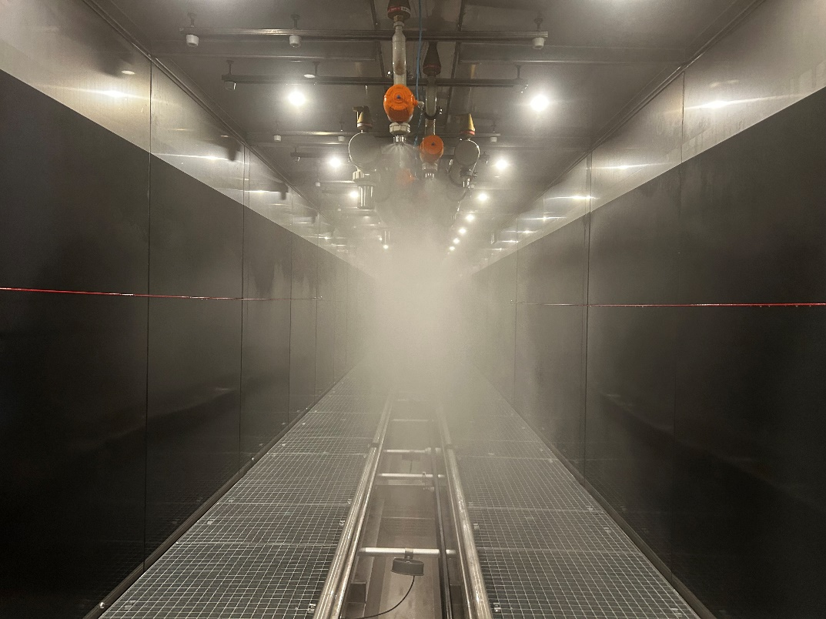
DG | 75% | 6000 | 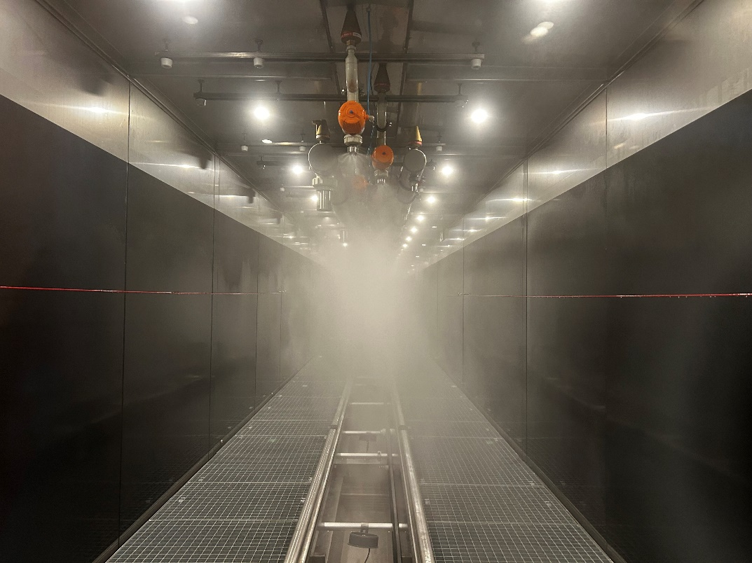
DG | 75% | 5000 | 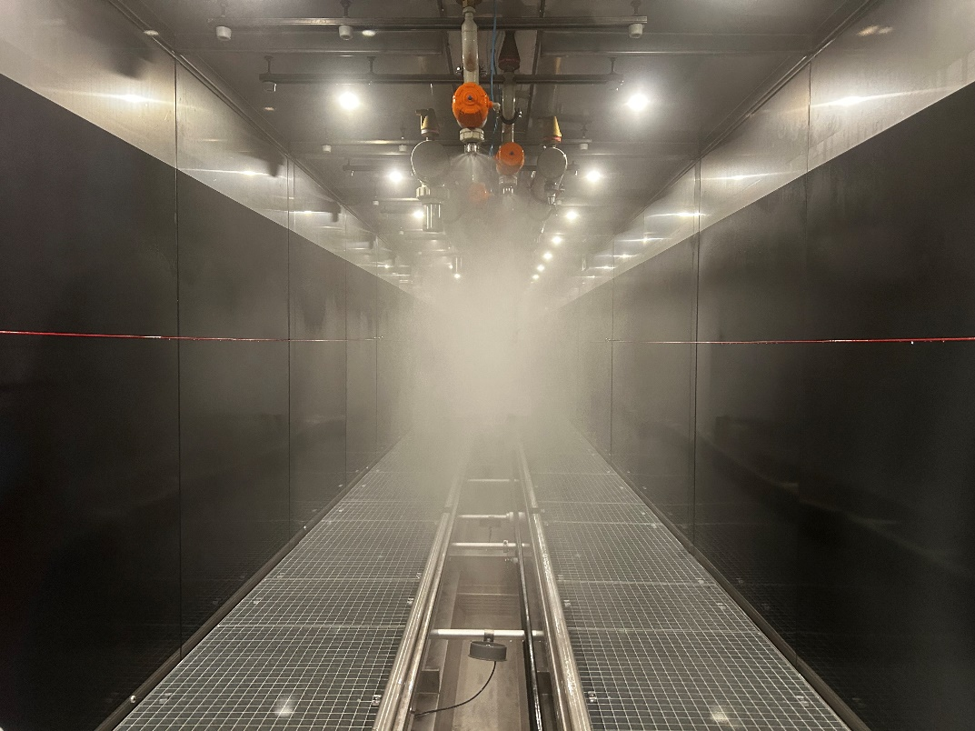
DG | 75% | 3600 | 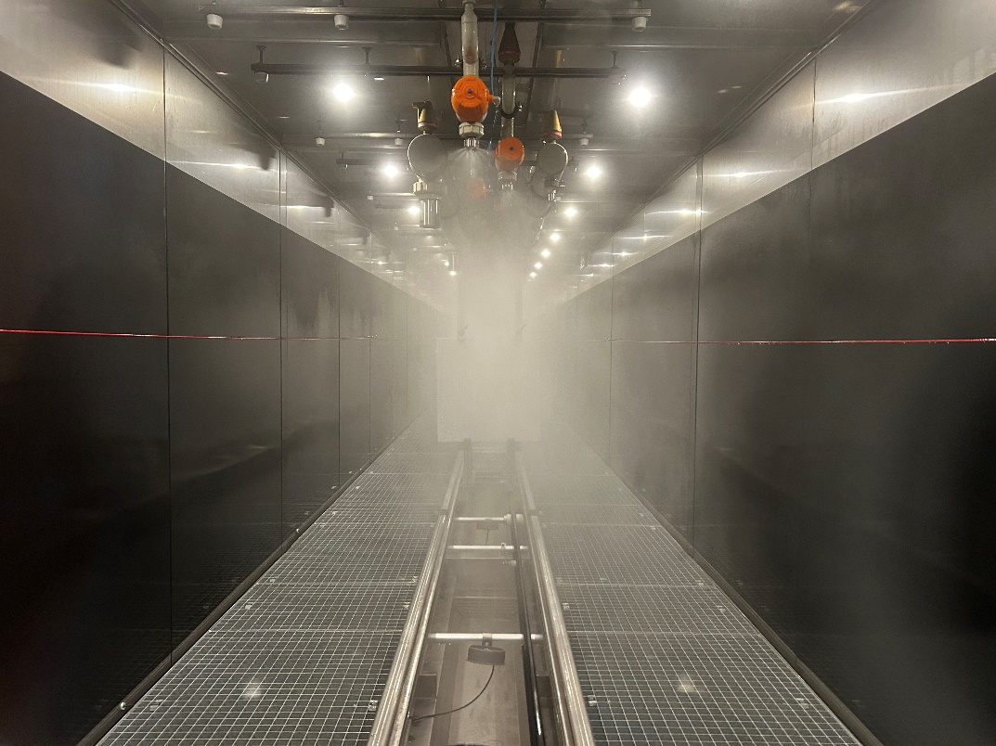
DG | 75% | 2300 | 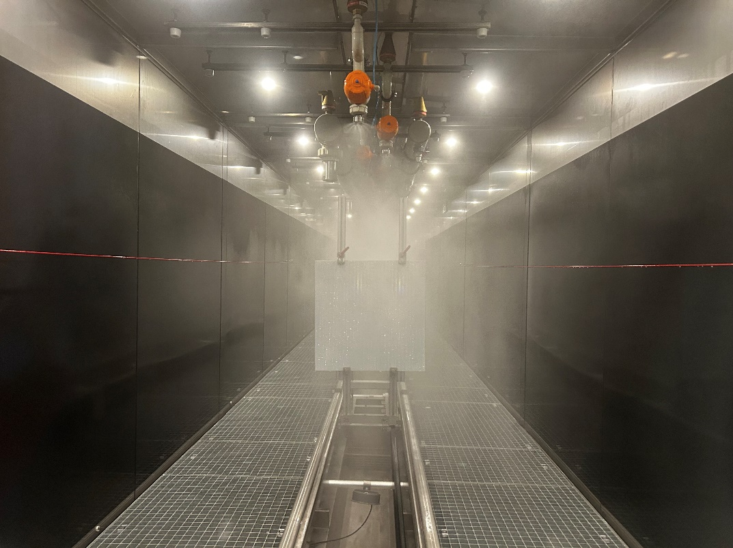
DG | 100% | 8000 | 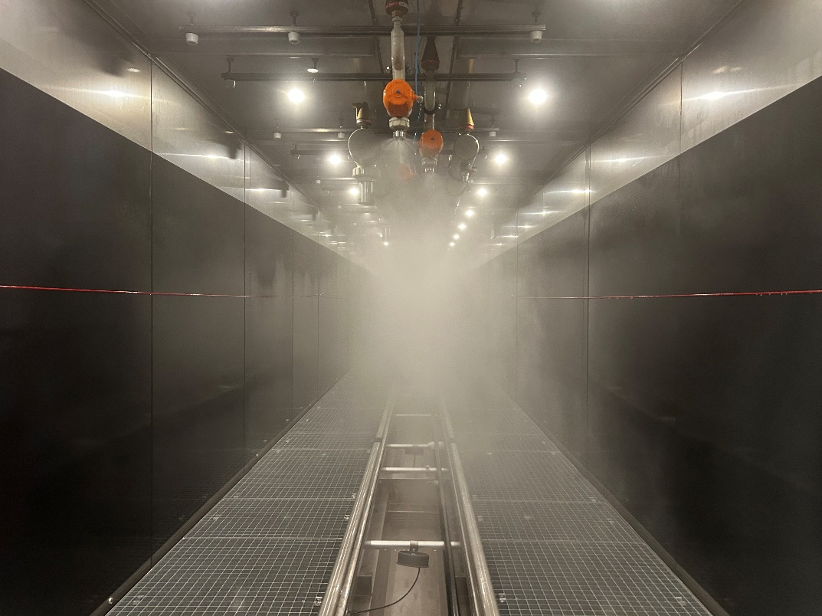
DG | 100% | 7000 | 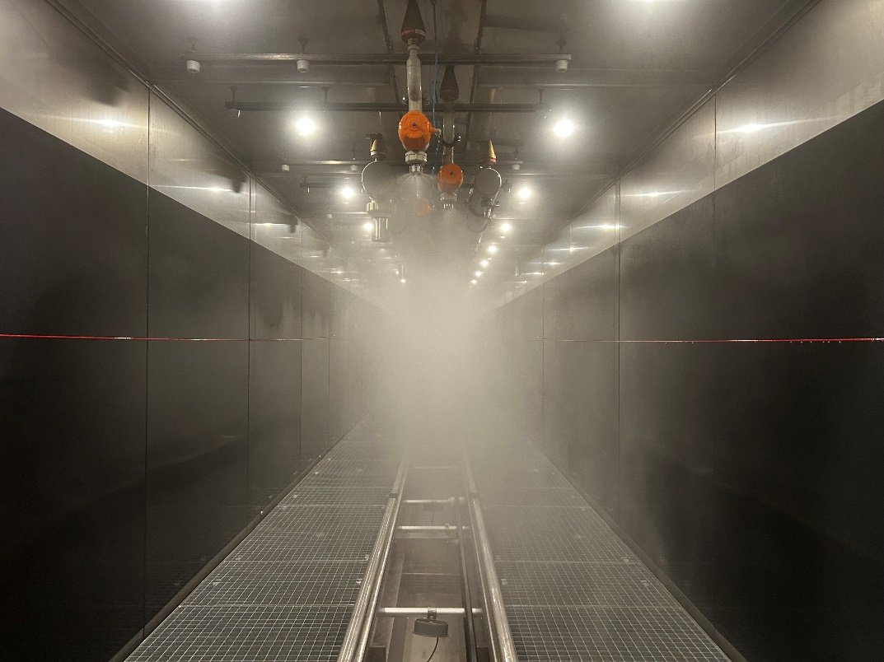
DG | 100% | 6000 | 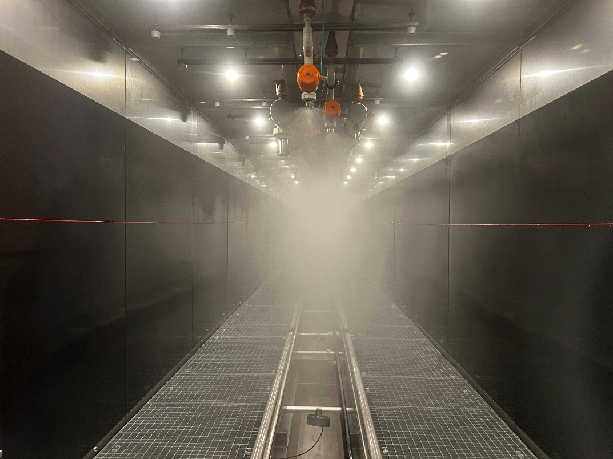
DG | 100% | 5000 | 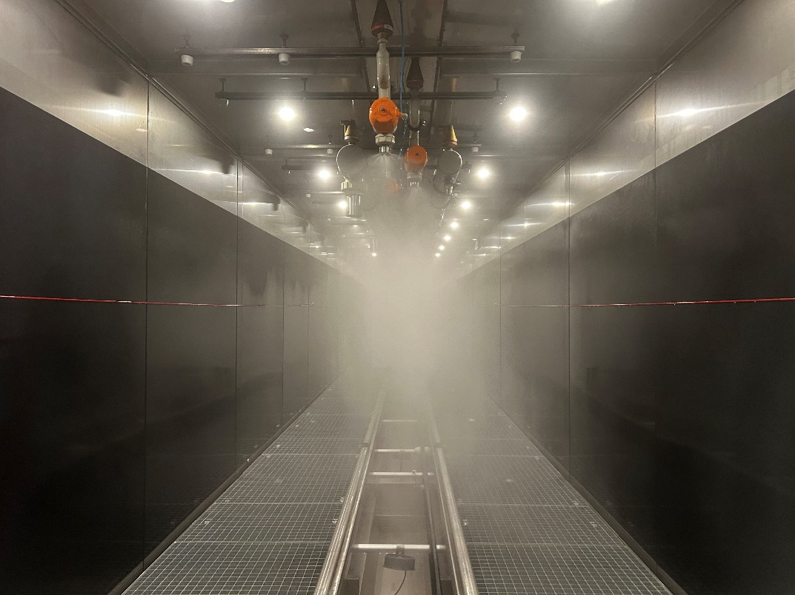
DG | 100% | 3600 | 